NLK Associates - Detailed Legal Management System Documentation
This document provides a complete step-by-step analysis and development roadmap for the
NLK Associates Legal Management System. The application is designed for law firms handling
Litigation and Non-Litigation legal work for banks, financial institutions, and private clients.
The system will digitize legal workflows including:
• Case Management
• Property Search & Verification
• TSR (Title Search Report)
• VET (Vetting Reports)
• CTC Soft Copy Management
• Document Workflow
• AI-Based Draft Generation
• Bank-wise Assignment Tracking
• Approval Workflow
• Client Communication

Client Shared Workflow Diagram
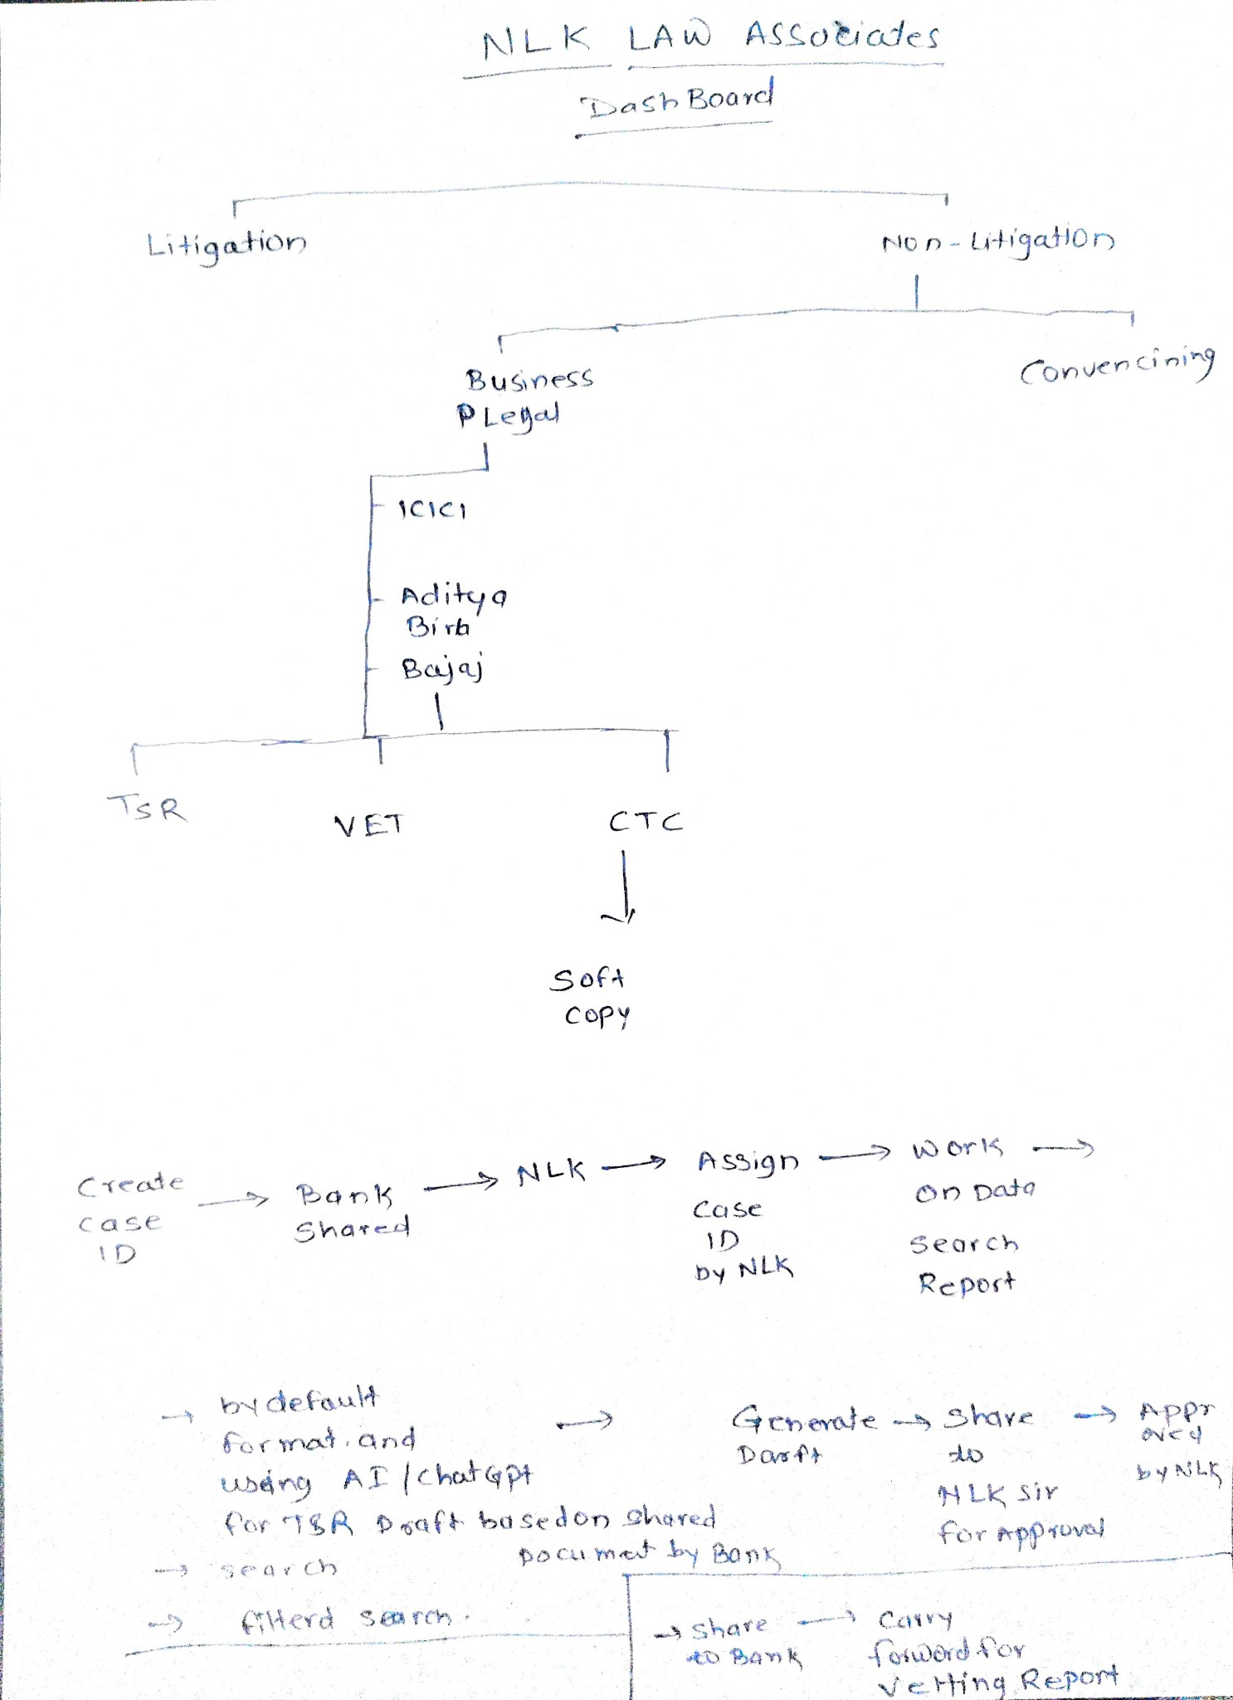
Reference workflow diagram shared by NLK Associates.

1. System Functional Architecture

Login & Authentication
Admin and Staff login with secure password authentication, role-based permissions, and activity logs.

Dashboard Module
Centralized dashboard displaying total cases, pending tasks, hearing schedules, approvals, and bank-wise statistics.

Litigation Module
Manage court cases, hearing dates, advocate assignment, case status, filing documents, and litigation history.

Non-Litigation Module
Manage property legal verification, agreements, conveyancing, TSR generation, mortgage documents, and compliance verification.

Business Legal Module
Bank-wise workflow handling such as ICICI, Aditya Birla, Bajaj, and other institutions.

Document Management System
Upload, categorize, preview, search, and archive legal documents in PDF, DOCX, JPG, and XLS formats.

TSR Generation Module
Generate Title Search Reports using property documents, search receipts, agreements, tax receipts, and AI-assisted draft generation.

VET Report Module
Generate legal vetting reports after title verification and document scrutiny.

CTC Module
Maintain certified true copy soft copies and secure document storage.

Approval Workflow
Draft reports are shared with NLK senior advocate for review, correction, and approval.

Bank Sharing Module
Approved reports and documents are securely shared with banks or clients.

AI Drafting Module
Use AI/ChatGPT integration for TSR draft generation based on uploaded legal documents.

2. Detailed Workflow Process

Step 1 - Case Creation
Admin or Staff creates a new Case ID with client details, property details, and bank information.

Step 2 - Bank Shared Documents
Bank uploads agreements, sale deeds, search receipts, tax receipts, OC documents, and supporting papers.

Step 3 - NLK Assignment
Case is assigned internally to legal staff or advocate for processing.

Step 4 - Document Verification
Uploaded documents are verified and categorized.

Step 5 - Search Process
Property search is conducted using IGR documents, agreements, search receipts, and encumbrance verification.

Step 6 - Draft Generation
AI-assisted TSR draft is generated automatically using uploaded records and predefined legal format.

Step 7 - Vetting
Senior legal reviewer verifies title flow, ownership chain, and legal observations.

Step 8 - Approval Workflow
Draft report is shared with NLK senior advocate for approval.

Step 9 - Final Report
Approved TSR/VET report is finalized in PDF and DOCX formats.

Step 10 - Share with Bank
Final approved report is shared with the bank/client.

3. Database Design
• Users Table
• Roles Table
• Case Master Table
• Bank Master Table
• Client Details Table
• Property Details Table
• Uploaded Documents Table
• TSR Reports Table
• VET Reports Table
• Approval Logs Table
• Activity Logs Table

4. Recommended Technology Stack
Frontend:
• HTML5
• CSS3
• Bootstrap / Tailwind CSS
• JavaScript / React
Backend:
• Node.js / Express OR Python Django / PHP Laravel
Database:
• MySQL / PostgreSQL
Storage:
• Local Server or AWS S3 Cloud Storage
Authentication:
• JWT Authentication
• Session Management
• Role-Based Access
AI Integration:
• OpenAI ChatGPT API for legal draft generation
Reports:
• PDF Generator
• DOCX Export
• Excel Export

5. Security & Compliance
• Role-based access control
• Encrypted password storage
• Secure file upload validation
• Daily backup management
• Document access logs
• Audit trail management
• HTTPS secure communication

6. Existing Legal File References Used
The development workflow references uploaded legal files such as:
• Search Receipts
• TSR Reports
• Sale Agreements
• Property Tax Receipts
• OC Documents
• GRAS Challans
• Property Search Results
• Macro-based Excel Search System

7. Proposed Application Screens
• Login Screen
• Dashboard
• Create Case Page
• Bank Document Upload
• Litigation Case Management
• Non-Litigation Workflow
• TSR Generation Screen
• VET Approval Screen
• Document Search & Filters
• Reports & Export Page
• Admin Settings

8. Future Enhancements
• WhatsApp integration
• Email automation
• E-signature workflow
• Mobile application
• Court hearing calendar sync
• OCR document scanning
• Voice-to-text legal dictation
• Advanced AI legal analysis

9. Conclusion
The NLK Associates Legal Management System will streamline legal operations, reduce manual paperwork, improve reporting accuracy, automate TSR drafting, and enhance communication between banks, legal staff, and senior advocates.

